Text Type Extraction using a Deep Learning Solution at the Character Level
Abstract. Text-type detection of a document is an essential pre-processing step in the implementations of many document-processing solutions, such as Optical Character Recognition (OCR) and machine translation. Specifically, text-type detection research for Bangla is very rare, with only a handful of solutions ever reported in the literature. In this paper, we present a lightweight, small footprint convolutional neural network, which detects handwritten and printed types of content directly from scanned mixed-type document images. The proposed model achieves 99.07% recognition accuracy for this specific two-type classification problem.
Keywords: Text-type Detection, Handwritten Content, Printed Content, CNN, Pattern Recognition.
- Introduction
OCR systems are a pipeline process, many processes aggregated to achieve the final output. These can be mainly separated into three stages: pre-processing stage (e.g. detection of languages), processing stage (e.g. segmentation), and post-processes stage (e.g. correction based on language model). As part of the pre-processing stage, one task is very important: detecting the mixture of handwritten verses printed content. Humans are great at detecting text-type, but for a machine, the solution is non-trivial.
Bangla is the national language of Bangladesh and second most widely spoken language of India, with 228 million native speakers and another 37 million as second language speakers [1][2], making it the fifth most-spoken native language and the seventh most spoken language by a total number of speakers in the world [3]. However, Bangla is considered to be a resource-poor language, as even the most basic resources of language automation such as OCRs, language models, parts of speech tagger, etc. are scarcely available.
Since the adoption of electronic workflow in offices and courts and many other segments of the country is still largely non-existant, many documents end up having handwritten components on top of the printed components. The ability to detect this type of variation is also very important for the design of any commercially successful Bangla OCR. A typical example is shown in Fig 1.
In this paper, we assume that we are part of an OCR processing pipeline and we have a functional character level segmentation module. So, we designed a Convolutional Neural Network (CNN) model to identify printed and handwritten content at the character-level from mixed-type scanned documents. We structured the rest of the paper on this assumption.
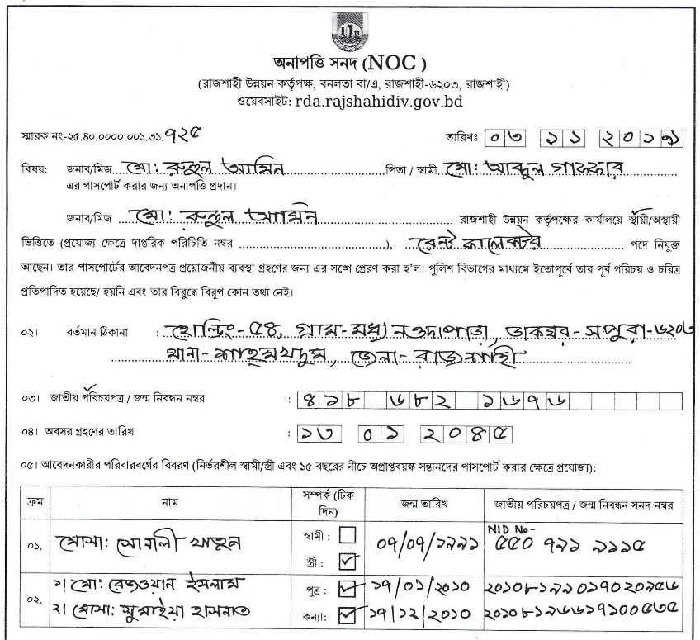
Fig. 1. Handwritten and printed content mixed in a primarily Bangla document
- Literature review
There is not much reported work for content type detection in scanned document images. We found a couple of works, including a paper from K. Zagoris et al. [4] who proposed a “Bag of Visual Words” (BoVW) model, which helps to identify and separate handwritten text from machine printed text. Firstly, they detected written text followed by descriptor calculations for each block based on BoVW. Finally, they identified the blocks as either handwritten, machine printed, or noise using a binary Support Vector Machine classifier. They used PRImA-NHM1, PRImA-UIBK1, and IAM handwriting datasets and achieved an overall performance of 84%, 92.2%, and 98.9% respectively.
Kavallieratou et al. [5] proposed a discriminant analysis method to separate machine printed and handwritten text, specifically focusing on IAM-DB and GRUHD databases, for English and Greek respectively. In their process pipeline, they preprocess the document images for page skew angle correction, then text localization, then area skew angle correction, and finally, line segmentation. After these preprocessing steps, they run their proposed method and classify printed and handwritten text. They report that their proposed method achieves an average classification accuracy of 98.2%.
A Microsoft team has proposed a transfer learning method to identify handwritten documents [6]. They published their project with Jupiter notebook using Azure Machine Learning (AML) package for Computer Vision (AMLPCV) model trained on the Coco Common Object in Context dataset containing more than 200,000 labeled images and 1.5 million object instances across 80 categories. They used Visual Object Tagging Tool (VOTT) to manually label a small set of public government contract data containing both machines printed text and handwriting and labeled two classes of handwriting objects in the VOTT tool – signatures and non-signature. Using this set of labeled data, they trained a custom handwriting detection model, which can detect handwritten words from a document image with promising accuracy.
- Dataset
To train our model, we used multiple publicly available datasets in addition to our own datasets for Bangla and English handwritten and printed characters. BanglaLekha-Isolated [7] and Ekush [8] character datasets are used for handwritten Bangla characters, NIST [9], and Chars74K datasets [10] are used for English handwriting characters. The Chars74K dataset is used for English printed characters. For printed Bangla characters, we created our own synthetic fonts dataset. BanglaLekha-Isolated has a total of 166,105 characters of 84 class images. We considered the basic 50 Bangla characters and 10 numeric character classes, a total of 60 classes totaling 118,698 images. In Ekush, 365,310 Bangla handwritten characters are available for 121 classes. We considered the basic 50 Bangla characters and 10 numeric classes, again a total of 60 classes comprising of 94,248 images. We merged these datasets into one Bangla handwritten dataset, which now has a total of 212,946 images. The Chars74K dataset has 814,255 English handwritten characters and the Chars74K dataset has 3,411 images of English handwritten characters. To make one dataset of English handwritten characters, we merged them to build a larger dataset of English handwriting characters totaling 817,666 images. Printed English characters were sourced from the Chars74K dataset and have a total of 62,992 images of English printed characters. For Bangla printed characters we have our own synthetic data of 11,038 images of printed Bangla characters. As we collected data from different sources, some images had a black background while others had a white background. To make a standard dataset for training and testing, we converted all images into a white background. Another point worth noting here is that we merged Bangla handwritten dataset and English handwritten datasets to avoid dataset imbalance. We shuffled them and built three datasets of different sizes, denoted as BN HW PR, EN HW PR, HW PR. Here BN stands for Bangla, EN stands for English, PR stands for Printed, HW stands for Handwriting. Table 1 shows details about these three datasets. We split our dataset into two parts: 80% for training the model and the other 20% for testing.
  - Data Augmentation
Having a large dataset is crucial for the performance of a deep learning model [11]. We can improve the performance of the model by augmenting the data we already have. Also, imbalanced training data can potentially have a severely negative impact on overall performance for CNN, and evidence shows that balanced training data yields the best results [12]. So, we made every effort to balance our datasets.

Dataset Name | Language | Type | Original Size
BN HW PR | BN | HW | 11,093
BN HW PR | BN | PR | 11,093
EN HW PR | EN | HW | 60,333
EN HW PR | EN | PR | 62992
HW PR | BN | HW | 11,038
HW PR | BN | PR | 11,038
HW PR | EN | PR | 11,038
HW PR | EN | HW | 11,038
Table 1. Number of samples in different datasets

We implemented four data augmentation techniques in our dataset to increase the size, which includes: (a) rotating the images in the range of 20 degrees, (b) flipping the images horizontally, (c) shifting the width by 20%, and finally, (d) shifting the height by 20%.
- Work Methodology
Practical OCRs have to pre-process a document to detect the language it is written in (e.g. a single language, or of mixed language) and the type of document (e.g. handwritten or printed or mixed) to run specific models for layout analysis, segmentation, and character recognition. In the work reported here, we aimed to build solutions (or ‘models’), which are optimized with respect to computational, and resource costs, rather than employing more extensive, complex but cost-expensive models such as VGG-16 [13], AlexNet [14], Inception-v3 [15], Transfer learning [16], and others. Below we describe our model architecture.
  - Proposed Models
Model architecture is a function of many variables. Since our datasets have many variations, so had to adapt and customize our basic model architecture. The architecture for all our datasets, we use one model and get better performance.
For all three datasets (BN HW PR, EN HW PR, HW PR), we propose a Convolutional Neural Network model [17] for classification of language and type. This model used convolution, max-pooling layer, fully connected dense layer, and some regularization methods like dropout with fairly complex architecture. In this model, one convolutional layer in the first block which is also an input layer with kernel size 5, and a filter size of 32. In this convolutional layer, the input image width is 64 and the height is 64 using activation function ReLU [18] with “Same” padding. The second block is also convolutional layer with kernel size 5, filter size 32 using activation function ReLU with padding, then max-pooling layer with pool size 2, followed by 25% dropout. Then two convolutional layers with kernel size 3, filter size 64 using activation function ReLU with padding, then max-pooling layer with a pool size of 2, strides size of 2, followed by 25% dropout. Then the output is flattened to an array and passed through a fully connected dense layer of 256 hidden units with the ReLU activation layer followed by a 50% dropout layer and passed through a fully connected dense layer of 1 nodes with “Sigmoid” activation. This final layer is our output layer for this model. Fig 2 shows the model.
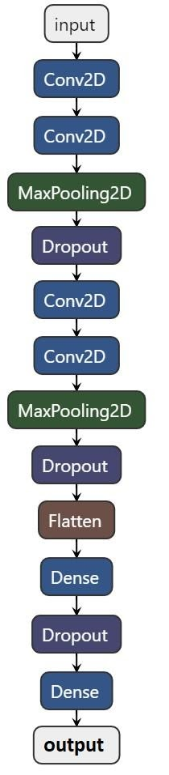
Fig. 2. BN HW PR, EN HW PR, HW PR detection model
To minimize the error of convolutional algorithms, optimization algorithms are widely used. Our proposed model used Adam optimizer [19] with a learning rate of 0.001. Adam optimization algorithms are used to update network weights iteratively in training data. Adam is an update of extension to a stochastic gradient descent algorithm. For its better performance, it is widely used in computer vision work.
To calculate the error for optimizing algorithms, we used binary cross-entropy function for our all datasets mode.
  - Epochs and EarlyStop
An issue with training neural networks is choosing how many training epochs to use. Too many epochs can result in the training dataset being over-fitted, while too few can result in the model being under-fitted. The EarlyStop feature has different metrics (or ‘arguments’) one can adjust to set up when the training process will stop. We set our initial epochs as 30. EarlyStop function monitors our test loss and stops the training when needed. In our research, our models for different datasets stop at different epochs based on model loss, details of which will be presented in the next section.
- Result Analysis
Our proposed methods have achieved very good results for both training and validation sets. We present these results below.
  - Learning Curve
A learning curve is a plot of the output model learning over time and experience. Learning curves are a commonly used machine learning testing method for algorithms, which incrementally learn from a training dataset. After each update during training, plots of the calculated results can be generated to display learning curves; the model can be tested on the training dataset and a holdout validation data set. Figs. 3 to 5 present our learning curves for the training test accuracy and loss for BN HW PR, EN HW PR, HW PR models respectively.

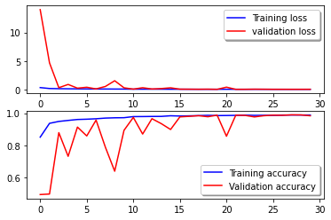
Fig. 3. Train test accuracy and loss for BN HW PR
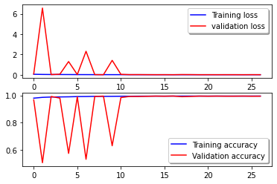
Fig. 4.Train test accuracy and loss for EN HW PR

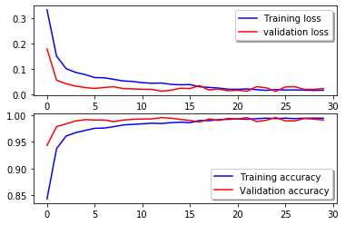
Fig. 5. Train test accuracy and loss for HW PR
  - Accuracy and Loss
We use different datasets to detect text-type at the character level. From training 3 different datasets, we get different accuracy and loss for different datasets. Table 2 shows the accuracy and loss of different datasets.

Model | Epoch | Train Acc. | Test Acc. | Train Loss | Test Loss
BN HW PR | 30 | 98.78% | 99.17% | 0.0335 | 0.0219
EN HW PR | 23 | 99.52% | 99.01% | 0.0128 | 0.0302
HW PR | 30 | 99.40% | 99.07% | 0.0170 | 0.0236

Table 2. Accuracy and loss of different models
  - Confusion Matrix
A confusion matrix is a table often used to define a classification model (or “classifier”) output on a collection of test data for which the true values are known. We observed the confusion matrix for all the datasets and found promising results. The confusion matrix of the validation set for all models is presented in Fig 6.

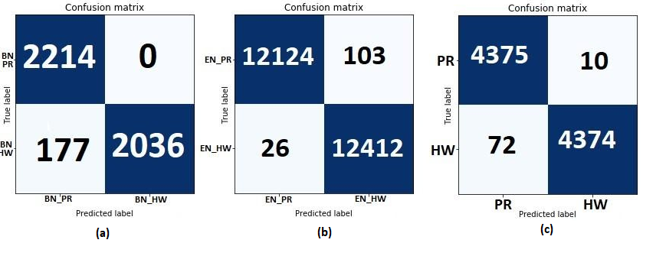
Fig. 6. Confusion matrix for (a) Bangla handwritten vs Bangla printed (b) English handwritten vs English printed (c) Handwritten vs Printed for both language recognition.
- Conclusion and Future Work
In this paper, we presented an effective model to identify handwritten and printed text in a mixed-type document. At the character-level, we achieved 99.07% validation accuracy. We have used a large character-level dataset to train our model and achieved excellent performance. Since our dataset is now only at the character level, our clear next step is to move the model to the page level and the word level. In addition to that, in the proposed model, we can only detect two types—handwritten and printed. In the future, we plan to adapt this to a multiple-type (e.g. letterpress, or typewritten text) content detection problem.

References
- “Bengali language - dialects & structure - mustgo.” [Online]. Available: https://www.mustgo.com/worldlanguages/bengali
- G. C. P. in Bangladesh Language, “Bangla,” Feb 2020. [Online]. Available: https://planeta.com/bangla
- “List of languages by number of native speakers,” May 2020. [Online]. Available: https://en.wikipedia.org/wiki/List of languages by number of native speakers
- K. Zagoris, I. Pratikakis, A. Antonacopoulos, B. Gatos, and N. Papamarkos, “Distinction between handwritten and machine-printed text based on the bag of visual words model,” Pattern Recognition, vol. 47, no. 3, pp. 1051–1062, 2014.
- E. Kavallieratou, S. Stamatatos, and H. Antonopoulou, “Machine-printed from handwritten text discrimination,” in Ninth International Workshop on Frontiers in Handwriting Recognition. IEEE, 2004, pp. 312–316.
- C. Yam, C. Wolff, and C. Wolff, “Making sense of handwritten sections in scanned documents using the azure ml package for computer vision and azure cognitive services,” Mar 2020,http://devblogs.microsoft.com/cse/2018/05/07/handwriting-detection-and-recognition -in-scanned-documents-using-azure-ml-package-computer-vision-azure-cognitive-services-ocr.
- M. Biswas, R. Islam, G. K. Shom, M. Shopon, N. Mohammed, S. Momen, and A. Abedin, “Banglalekha-isolated: A multi-purpose comprehensive dataset of handwritten bangla isolated characters,” Data in brief, vol. 12, pp. 103–107, 2017.
- A. S. A. Rabby, S. Haque, M. S. Islam, S. Abujar, and S. A. Hossain, “Ekush: A multipurpose and multitype comprehensive database for online off-line bangla handwritten characters,” in International Conference on Recent Trends in Image Processing and Pattern Recognition. Springer, 2018, pp. 149–158.
- P. J. Grother, “Nist special database 19 handprinted forms and characters database,” National Institute of Standards and Technology, 1995.
- T. De Campos, R. Bodla, and M. Varma, “The chars74k dataset,” 2009.
- N. Dvornik, J. Mairal, and C. Schmid, “On the importance of visual context for data augmentation in scene understanding,” IEEE Transactions on Pattern Analysis and Machine Intelligence, 2019.
- D. Masko and P. Hensman, “The impact of imbalanced training data for convolutional neural networks,” 2015.
- K. Simonyan and A. Zisserman, “Very deep convolutional networks for large-scale image recognition,” arXiv preprint arXiv:1409.1556, 2014.
- A. Krizhevsky, I. Sutskever, and G. E. Hinton, “Imagenet classification with deep convolutional neural networks,” in Advances in neural information processing systems, 2012, pp. 1097–1105.
- C. Szegedy, V. Vanhoucke, S. Ioffe, J. Shlens, and Z. Wojna, “Rethinking the inception architecture for computer vision,” in Proceedings of the IEEE conference on computer vision and pattern recognition, 2016, pp. 2818–2826.
- L. Torrey and J. Shavlik, “Transfer learning,” in Handbook of research on machine learning applications and trends: algorithms, methods, and techniques. IGI Global, 2010, pp. 242–264.
- S. Albawi, T. A. Mohammed, and S. Al-Zawi, “Understanding of a convolutional neural network,” in 2017 International Conference on Engineering and Technology (ICET). IEEE, 2017, pp. 1–6.
- V. Nair and G. E. Hinton, “Rectified linear units improve restricted boltzmann machines,” in Proceedings of the 27th international conference on machine learning (ICML-10), 2010, pp. 807–814.
- D. P. Kingma and J. Ba, “Adam: A method for stochastic optimization,” arXiv preprint arXiv:1412.6980, 2014.

